**Authorizing a new User**

When a user creates a GSI Cost Tool account, the account is initially inactive. This is to prevent malicious users from creating accounts and then creating data randomly. (Note: this behavior can be changed if the COR wants to allow unverified users)

A user with 'superuser' (administrative) permissions needs to go into the system and set the user as to active.

When a superuser logs into the GSI Cost Tool, the menu in the upper right corner of the screen has 3 options. Use the first option to open the 'GSI Cost Tool Admin Page'

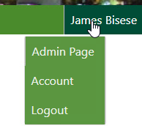

On the GSI Cost Tool Admin Page the superuser can add, edit, and delete data. The superuser can select any option by selecting the name of the option, or the 'Change' menu button.

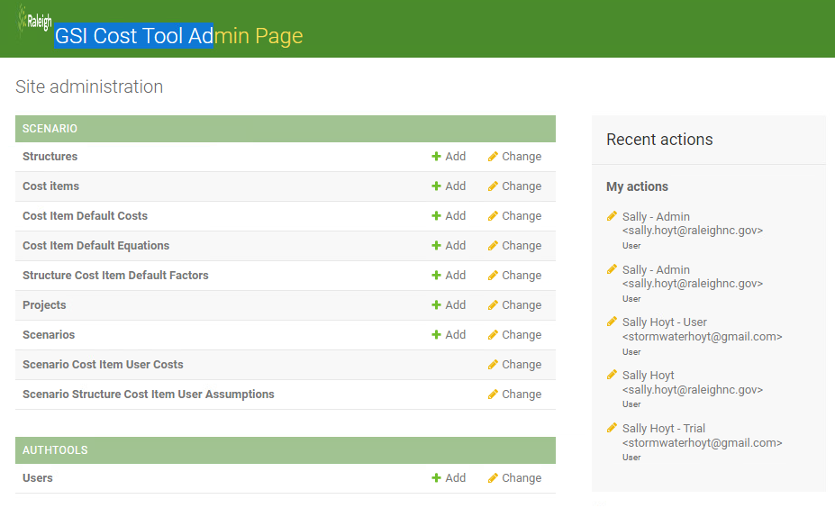

To set the user as active, select the AUTHTOOLS **Users** from the menu of options. In this image, the example account we want to change is 'Stephanie Seeber'. Not that the user of this account has never logged in, and their account is not active. Find the user you want to make active and click their NAME. This will open the editor screen

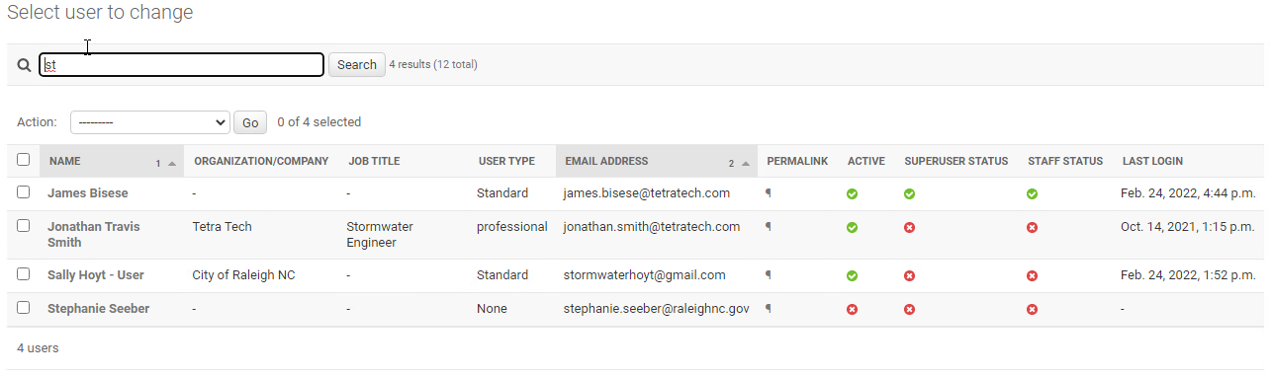

Below is the editor screen for a single user. In order for users to be able to login and create Projects and Scenarios, their account must be marked Active. If the user is on City of Raleigh staff and should be able to see all user's data, then the 'Staff status' checkbox should also be set. If the user should be able to update and delete all data in the system, the 'Superuser status' checkbox should be set. Once the required changes have been made, click the SAVE button at the bottom of the page.

Here are the special permissions outlined on the Change user form within the Admin Pages:

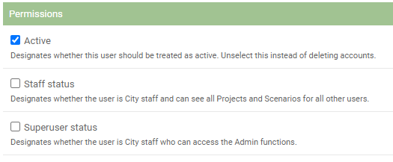

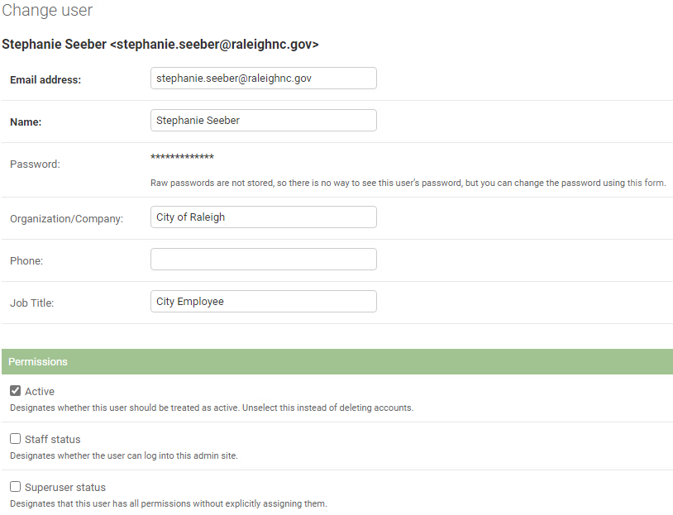

On the list of users, the account information has been changed. The user should be able to login now.

